

INTERNSHIP REPORT APPROVAL FORM

August 12, 2021

With immense pleasure, this is to approve that the students of VELLORE INSTITUTE OF TECHNOLOGY i.,e

Pranav Mule (19BCE10334)
Vishwajeet Patil (19MIM10032)
Ayush Kakar (18BEC0715)

successfully completed their Project and Project Report on “3D PRINTER MATERIAL PREDICTION” under our guidance.
We are highly impressed with the work that they have done and commend them on their quick grasping skills. They have shown good intent to learn and have put the knowledge gained into application in the from of this project. We appreciate the hard work and commitment shown by them.
We, hereby approve that this document is completely checked and accepted by SmartBridge Technical Team. Its been an absolute pleasure to educate and mentor these students. We hope that this document will also serve as a Letter of Recommendation, to whomsover applied.

We wish them success in all future endeavors and a great career ahead.

3D PRINTER MATERIAL PREDICTION

INTRODUCTION:

Python is a popular programming language. It was created by Guido van Rossum, and released in 1991. It is used for web development (server-side), software development, mathematics, system scripting. Python works on different platforms (Windows, Mac, Linux, Raspberry Pi, etc). Python has a simple syntax similar to the English language. Python has syntax that allows developers to write programs with fewer lines than some other programming languages. Python runs on an interpreter system, meaning that code can be executed as soon as it is written. This means that prototyping can be very quick. Python can be treated in a procedural way, an object-orientated way or a functional way.

Artificial intelligence is a branch of computer science that aims to create intelligent machines. It has become an essential part of the technology industry. Research associated with artificial intelligence is highly technical and specialized. The core problems of artificial intelligence include programming computers for certain traits such as Knowledge, Reasoning, Problem solving, Perception, Learning, Planning, Ability to manipulate and move objects.
Machine learning is also a core part of AI. Learning without any kind of supervision requires an ability to identify patterns in streams of inputs, whereas learning with adequate supervision involves classification and numerical regressions. Classification determines the category an object belongs to and regression deals with obtaining a set of numerical input or output examples, thereby discovering functions enabling the generation of suitable outputs from respective inputs. Mathematical analysis of machine learning algorithms and their performance is a well-defined branch of theoretical computer science often referred to as computational learning theory.
Machine perception deals with the capability to use sensory inputs to deduce the different aspects of the world, while computer vision is the power to analyze visual inputs with a few sub- problems such as facial, object and gesture recognition.

Objectives of Research:

This will be useful to predict material which would be more suitable for making the 3D model. Specifically this project will be more useful for the Mechanical Engineers. In this project the input parameters are like Layer Height (mm),Wall Thickness (mm),Infill Density (%),Infill Pattern (honey comb, grid),Nozzle Temperature (Cº),Bed Temperature (Cº),Print Speed (mm/s),Fan Speed (%), Roughness (µm),Tension (ultimate), Strength (MPa), Elongation (%). Based on these parameters this model predicts the best material to be used.
This model will predict whether to use abs or pla. Acrylonitrile butadiene styrene(abs) is a common thermoplastic polymer. ABS is amorphous and therefore has no true melting point. ABS is a terpolymer made by polymerizing styrene and acrylonitrile in the presence of polybutadiene.
Polylactic acid or polylactide (PLA) is a thermoplastic aliphatic polyester derived from renewable biomass, typically from fermented plant starch such as from corn, cassava, sugarcane or sugar beet pulp. In 2010, PLA had the second highest consumption volume of any bioplastic of the world.
Infill density is the amount of filament printed inside the object, and this directly relates to the strength, weight and printing duration of your print. Different 3D print infill types, or infill patterns, can affect the object's final strength without changing the print's weight or filament used.

PROBLEM STATEMENT:

The aim of the study is to determine the best material which will be perfect for the given use case. Where there are eleven setting parameters and one output parameters. Based on these input parameters we have to predict the best material for model.
We have improved the accuracy of prediction by using decision tree algorithm. We also tried using various other algorithms like logistic regression, knn, svm linear, svm non linear (kernel) etc. But the accuracy score was high(i.e 92%) while using decision tree so we have implemented the model using decision tree algorithm.
After training the model the model must be deployed in the cloud using ibm Watson machine learning tool. We have used nodejs to create an simple, user friendly and responsive user interface for getting input from the user and predicting the result.

REVIEW OF LITERATURE:

S. Eshraghi, S. DasMechanical and microstructural properties of polycaprolactone scaffolds with one-dimensional, two-dimensional, and three-dimensional orthogonally oriented porous architectures produced by selective laser sintering Acta Biomater. From this article we refered the ranges for the various input features. For example the layer height for abs must be
0.05 to 0.1 mm and the layer height is different for pla and for pla the wall thickness must be 0.4mm of nozzle size. We gaot various informations like these from this article.
W.-I .Cho ,S.-J. Na, C. Thomy , F. VollertsenNumerical simulation of molten pool dynamics in high power disk laser welding J. Mater. Process. Technol. From this article we got information for the temperature range that must be used for the nozzle temperature and bed temperature and the way it affects the quality and looks of the product to be made.These informations in turn will be very useful in making of the product.
J. Woo Jung, H.-G. Yi, T.-Y. Kang, W.-J. Yong, S. Jin, W.-S. Yun, D.-W. ChoEvaluation of the effective diffusivity of a freeform fabricated scaffold using computational simulation J. Biomech.From this article we gained knowledge and information about the fabrication process how it is done, under what case it is done, what is the best condition under which it can be done and so on.

DATA COLLECTION:

For the given problem statement 3D material prediction from Kaggle. Kaggle is an online community of data scientists and machine learners, owned by Google LLC. Kaggle allows users to find and publish data sets, explore and build models in a web-based data-science environment, work with other data scientists and machine learning engineers, and enter competitions to solve data science challenges. Kaggle got its start by offering machine learning competitions and now also offers a public data platform, a cloud-based workbench for data science, and short form AI education. Kaggle also provides various services like Machine learning competitions, kaggle kernals, kaggle learn, jobs board etc.
The dataset which we got from kaggle consists of 67 rows and 12 columns. Among which Material is the ouput parameter and the other 11 columns are input parameters.By using these input parameters the output i.e the best material to be used should be predicted which is the main objective of this project.
arXiv (pronounced "archive"—the X represents the Greek letter chi [χ]) is a repository of electronic preprints (known as e-prints) approved for posting after moderation, but not full peer review. It consists of scientific papers in the field of mathematics, physics, astronomy, electrical engineering, computerscience, quantitativebiology, statistics, mathematical,finance and economi cs, which can be accessed online. In many fields of mathematics and physics, almost all scientific papers are self-archived on the arXiv repository. Begun on August 14, 1991, arXiv.org passed the half-million-article milestone on October 3, 2008, and had hit a million by the end of 2014. By October 2016 the submission rate had grown to more than 10,000 per month.

METHODOLOGY

EXPLORATORY DATA ANALYSIS

    - FIGURES AND TABLES DATASET:
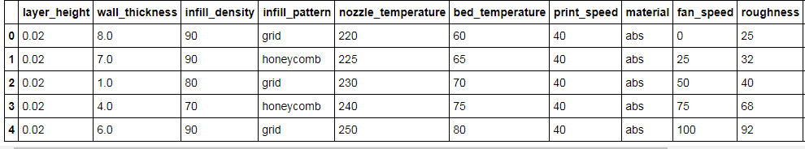

Figure 4.1 Dataset

CORRELATION:

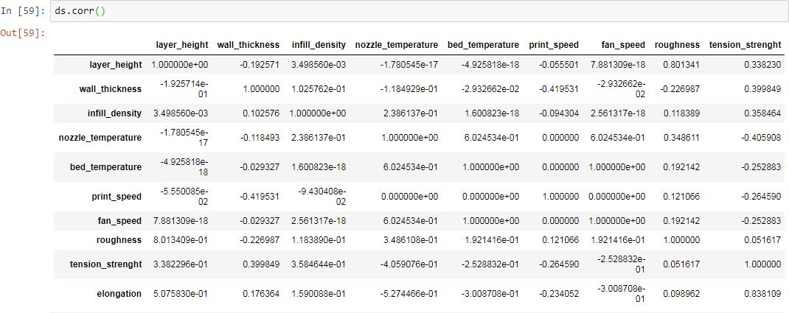

Figure 4.2 Correlation

HEAT MAP:

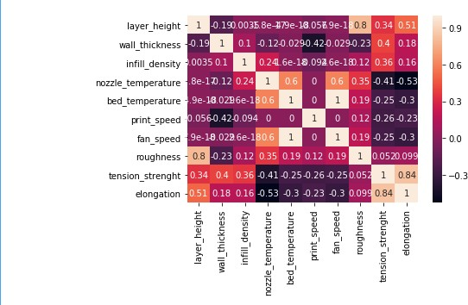

Figure 4.3 Heat Map

ROC CURVE

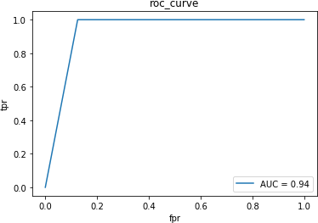

Figure 4.4 ROC Curve

DATA MODELLING:

We have used Decision Tree for this model ,which comes under classification,regression algorithms.After making predictions using logistic regression,svm,random forest ,decision tree algorithms ,we have chosen decision tree as it gives the highest accuracy score.
    - The general motive of using Decision Tree is to create a training model which can use to predict class or value of target variables by learning decision rules inferred from prior data(training data).The understanding level of Decision Trees algorithm is so easy compared with other classification algorithms. The decision tree algorithm tries to solve the problem, by using tree representation. Each internal node of the tree corresponds to an attribute, and each leaf node corresponds to a class label.
In this model we have used the following packages,

- Numpy

- Pandas

- accuracy_score(metrics)

- LabelEncoder

- MinMaxScaler

- train_test_split

- DecisionTreeClassifier

we have done label encoding for 3 rd column and proceeded with it.With an accuracy score of 0.92857
,we have finally chosen decion tree classifier and trained the model with 57 datasets.

We have used Watson Machine Learning for saving and deploying our model in ibm cloud. Watson is a question-answering computer system capable of answering questions posed in natural language, developed in IBM's DeepQA project by a research team led by principal investigator David Ferrucci. Watson was named after IBM's first CEO, industrialist Thomas J. Watson. The computer system was initially developed to answer questions on the quiz
show Jeopardy! and, in 2011, the Watson computer system competed on Jeopardy! against legendary champions Brad Rutter and Ken Jennings winning the first place prize of $1 million.
In February 2013, IBM announced that Watson software system's first commercial application would be for utilization management decisions in lung cancer treatment at Memorial Sloan Kettering Cancer Center, New York City, in conjunction with WellPoint (now Anthem). IBM Watson's former business chief, Manoj Saxena, says that 90% of nurses in the field who use Watson now follow its guidance.
Node-RED is a flow-based development tool for visual programming developed originally by IBM for wiring together hardware devices, APIs and online services as part of the Internet of Things.
Node-RED provides a web browser-based flow editor, which can be used to create JavaScript functions. Elements of applications can be saved or shared for re-use. The runtime is built on Node.js. The flows created in Node-RED are stored using JSON. Since version 0.14 MQTT nodes can make properly configured TLS connections.
In 2016, IBM contributed Node-RED as an open source JS Foundation project.

REFERENCE:

www.kaggle.com

Kaggle is an online community of data scientists and machine learners, owned by Google LLC. Kaggle allows users to find and publish data sets, explore and build models in a web-based data-science environment, work with other data scientists and machine learning engineers, and enter competitions to solve data science challenges. Kaggle got its start by offering machine learning competitions and now also offers a public data platform, a cloud-based workbench for data science, and short form AI education.
- https://machinelearningmastery.com

It is a machine learning website which is a large repository of information regarding data mining which would be very useful for beginners as well as experts.

- https://www.geeksforgeeks.org/decision-tree/

GeeksForGeeks is a collection of programming/algorithm/interview questions which is run by a team of experts. This platform is created to provide well written, well thought and well explained solutions for selected questions.This website has 5 main contributors.
- https://arxiv.org
arXiv (pronounced "archive"—the X represents the Greek letter chi [χ]) is a repository of electronic preprints (known as e-prints) approved for posting after moderation, but not full peer review. It consists of scientific papers in the field of mathematics, physics, astronomy, electrical engineering, computerscience, quantitativebiology, statistics, mathematical,finance and economi cs, which can be accessed online. In many fields of mathematics and physics, almost all scientific papers are self-archived on the arXiv repository. Begun on August 14, 1991, arXiv.org passed the half-million-article milestone on October 3, 2008, and had hit a million by the end of 2014. By October 2016 the submission rate had grown to more than 10,000 per month.
- https://www.analyticsvidhya.com/

Analytics Vidhya brings you the power of community that comprises of data practitioners, thought leaders and corporates leveraging data to generate value for their businesses. Learn from the resources developed by experts at AnalyticsVidhya, participate in hackathons, master your skills with latest data science problems and showcase your skills to the world.

CONCLUSION:
In today’s fastgrowing World Mchine Learning has an importanat role to play. Machine Learning has various applications like predicting diseases, predicting success and so on. Machine learning is an application of artificial intelligence (AI) that provides systems the ability to automatically learn and improve from experience without being explicitly programmed. Machine learning focuses on the development of computer programs that can access data and use it learn for themselves.
Using this machine learning concept we have done a project to predict the best material to be used for a 3d product. This in turn will be very useful because it reduces the time and human work in predicting the material to be used. In human prediction errors may also occur but when it comes to machine learning the errors are greatly reduced and the acuuracy is more. So in turn the prediction will be more better.
Thus we hope this 3D material prediction model will be very useful in predicting the required material.

